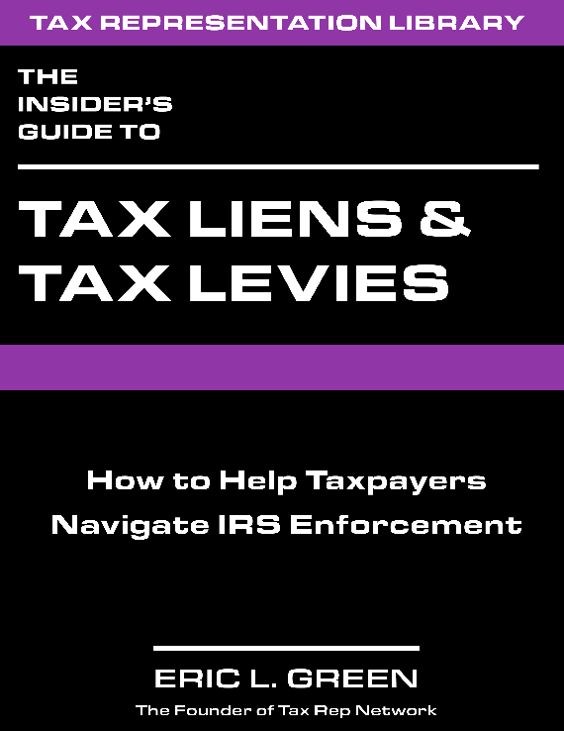
For taxpayers that owe money to the government, tax liens and tax levies become the bane of their existence. Tax liens create havoc, shutting off access to credit and making life difficult for taxpayers to run both their business as well as their personal life. Tax levies can be more destructive, cleaning out bank accounts with little to no notice and garnishing wages, creating economic headaches for the taxpayer.
It does not have to be this way. In this new guide author Eric Green dives into the mechanics of how liens and levies work, and the options tax professionals have to resolve these issues and avoid or remove liens and levies.
With one quick read through this guide you will know more about IRS enforcement than 99% of tax professionals, and can help your clients work through these issues with confidence.
The Guide Includes:
- An Overview of why the IRS uses tax liens and tax levies
- The flow of IRS collection
- Federal Tax Liens
- Foreclosure and Redemption of Tax Liens
- Federal Tax Levies
- 27 exhibits
- The Lien Checklist
- Sample pricing list for these services
- 11 Sample letters to use in your practice
- The top 20 questions and answers about liens and levies
- 5 case studies
https://tgpublish.com/book-liensx1/

